


Faculty of Computers and Artificial Intelligence
Cairo University
IS313 – Data Warehouse
Data Warehouse Project
Section: IS S1,2

Name | ID
Mohannad Salah | 20231182

Data set source: Kaggle
Dataset: Bike Store Relational Database | SQL

Deliverables:
- Physical model of the source system (the tables from which you will build your model).
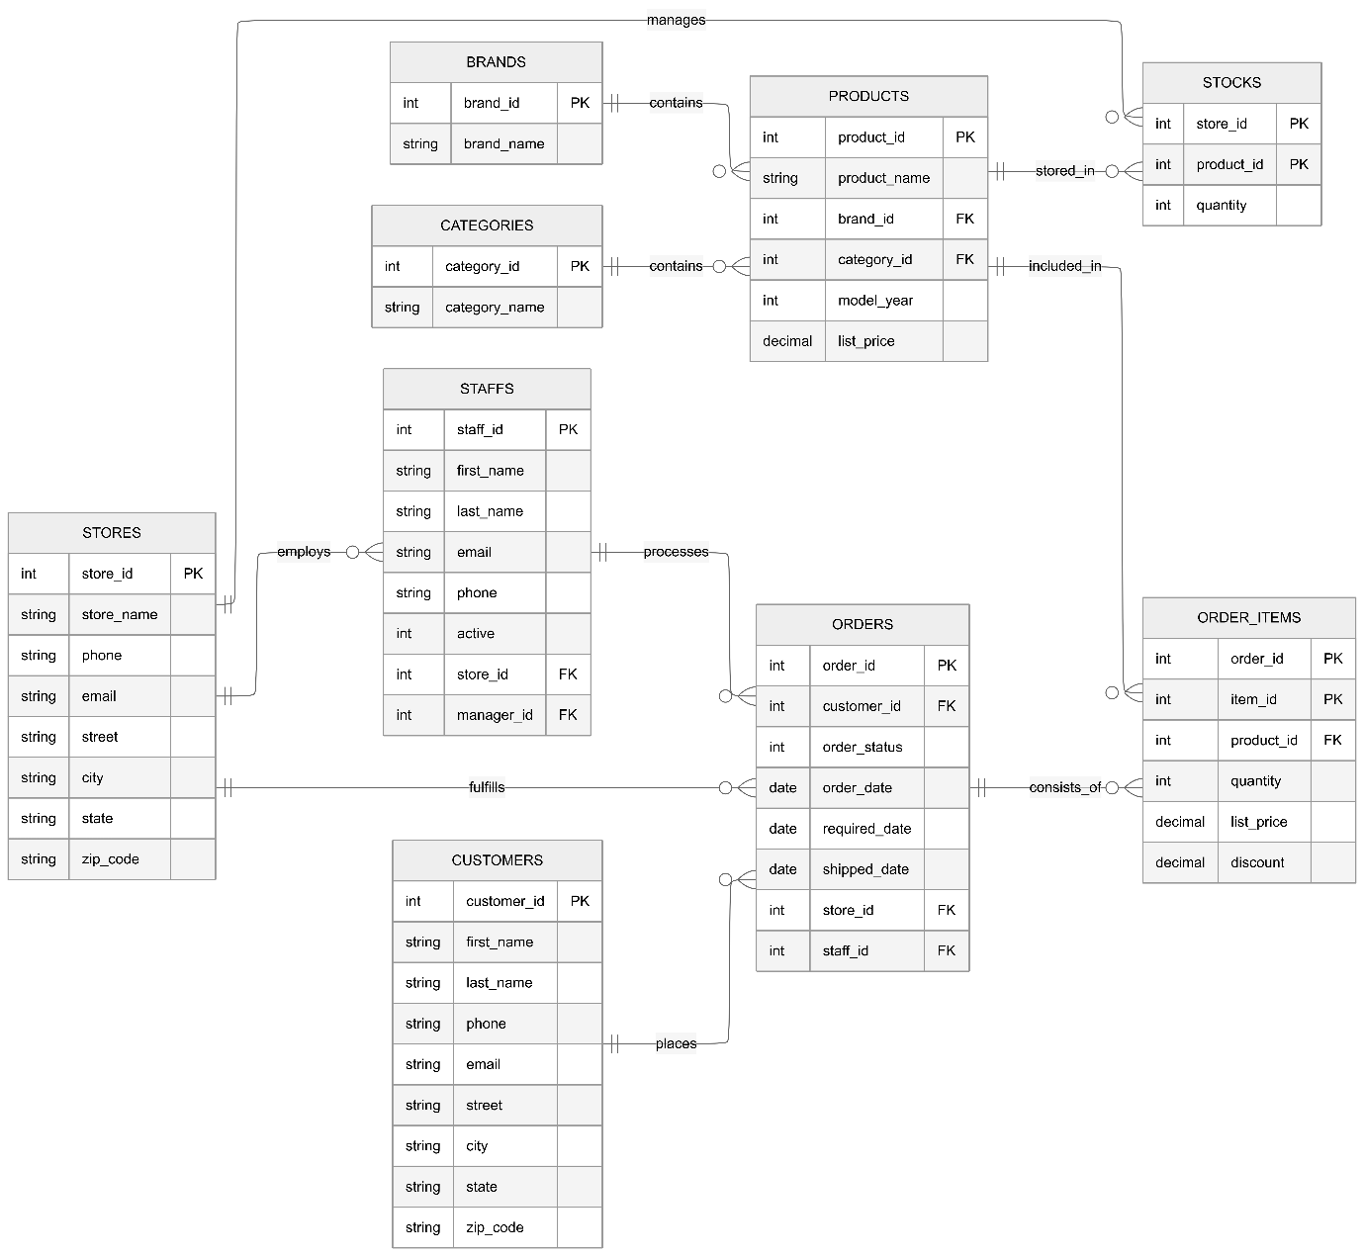

- Source Description:
- STG_Brands: Stores the manufacturer names for the bicycles.
Columns: brand_id, brand_name
- STG_Categories: Defines the different types of bicycles available.
Columns: category_id, category_name

- STG_Customers: Contains profile and contact information for all registered customers.
Columns: customer_id, first_name, last_name, phone, email, street, city, state, zip_code
- STG_Order_Items: Lists specific product details, pricing, and discounts for every order.
Columns: order_id, item_id, product_id, quantity, list_price, discount
- STG_Orders: Tracks the header-level details including order status and key fulfillment dates.
Columns: order_id, customer_id, order_status, order_date, required_date, shipped_date, store_id, staff_id
- STG_Products: Serves as the master catalog for all bicycle models and their specifications.
Columns: product_id, product_name, brand_id, category_id, model_year, list_price
- STG_Staffs: Maintains records of employees, their roles, and their assigned store locations.
Columns: staff_id, first_name, last_name, email, phone, active, store_id, manager_id
- STG_Stocks: Records the current inventory levels for every product across different store locations.
Columns: store_id, product_id, quantity
- STG_Stores: Contains information and locations for the physical retail outlets.
Columns: store_id, store_name, phone, email, street, city, state, zip_code

- Dimensional model
- Business Processes Modeled
We have selected three core business processes from the Bike Store system to provide a 360-degree view of operations:
- Sales Transactions: Tracking the individual movement of bicycles from the store to the customer. Using list_price and discount from order_items.csv.
- Shipping & Logistics: Monitoring delivery performance by comparing required_date and shipped_date from the orders.csv file, and calculates the late delivery risks
- Order Management & Financials: Analyzing order success and store-level performance using order_status and store_id. It summarizes the overall financial benefit of transactions across different store locations and staff members.
- Grain of the Fact Tables
The grain defines the level of detail for a single row in each fact table:
- Fact_Sales: One row per item within a specific order (Atomic/Line-item grain). This allows for the highest level of analytical granularity.
- Fact_Shipping: One row per shipment transaction for a given order and store location.
- Fact_Orders: One row per unique Order ID (Header level grain). This summarizes the entire transaction regardless of how many items were purchased.

- Type of Each Fact Table
- Fact_Sales
- Type: Transactional Fact Table.
- Records specific sales events to track individual product and revenue generation at the line-item level.
- KPIs:
  - Total Net Revenue per Brand: The sum of SalesAmount minus Discount to show actual earnings per brand.
  - Discount Rate Percentage: The total discount value divided by total SalesAmount to monitor price reductions.
  - Top Selling Products per quantity: A ranking based on the total Quantity sold to identify popular items.
  - Revenue per Brand: The total earnings generated by specific manufacturers to identify high-value brands.

- Fact_Shipping
- Type: Transactional Fact Table.
- Records the shipping lifecycle to measure delivery performance.
- KPIs:
  - Late Shipment Rate per Store: The percentage of total orders per store where delivery occurred after the required date.
  - Average Fulfillment Time: The average number of days taken to process and ship an order from the date it was placed.

- Fact_Orders
- Type: Transactional Fact Table.
- Captures the summarized financial and status outcome of a transaction to provide a view of overall business health.
- KPIs:
  - Average Order Value: The total order profit divided by the total number of unique orders.
  - Order Success Rate: The percentage of transactions that reached a completed status without being cancelled or rejected. As well as the percentage of orders that were rejected, processed and rejected to help in comparison.
  - Average items count: The average number of items contained within a single transaction.

- Dimensions and Their Types
We implemented 6 Dimension tables using an SCD Type 1 , SCD Type 0(Slowly Changing Dimension) and Static strategy.
Dimension Name | Type | Description
Dim_Date | Static / Generated | A generated time dimension based on the order_date, required_date and shipped_date covering years 2016–2018.
Dim_Customer | SCD Type 1 | Contains customer names and contact details. It overwrites the old data as the customer data doesn’t change frequently so there is no need to keep history.
Dim_Product | SCD Type 2 | Stores product names, categories, brands, and model years. Maintains full history by expiring the old record and inserting a new version whenever a change is detected.
Dim_Geography | SCD Type 1 | Maps store and the customer locations for the orders.
Dim_Staff | SCD Type 2 | Stores staff names, emails, and active status. Maintains full history by expiring the old record and inserting a new version whenever staff details change.
Dim_Order_Status | Static | Acts as a fixed lookup table for the order lifecycle, mapping status codes to descriptions: Pending, Processing, Rejected, and Completed.

- Measures and Data Types
Fact Table | Measure | Data Type | Description
Fact_Sales | SalesAmount | Decimal(18,2) | Total revenue for the item.  Quantity * list_price
Fact_Sales | Quantity | Integer | Number of units sold.
Fact_Sales | Discount | Decimal(18,2) | Discount value applied.
Fact_Shipping | ActualDays | Integer | Real time taken for delivery. Difference between shipped_date and order_date
Fact_Shipping | ScheduledDays | Integer | Promised delivery time.  Orderdate – requireddate
Fact_Shipping | LateRiskFlag | Integer (0/1) | Binary indicator of late delivery.  If shippeddate>requireddate
Fact_Orders | Order_Total_Value | Decimal(18,2) | Total profit per order.
Fact_Orders | Item_Count | Integer | It counts the number of unique items within a single order_id
Measures are the quantitative values stored in fact tables used for KPI calculations:

- Galaxy Schema Model:

- Screenshots of the data flow tasks, and control flow tasks used for building the DWH

- Bike_Store_STG:
  - Flow Type: Control Flow
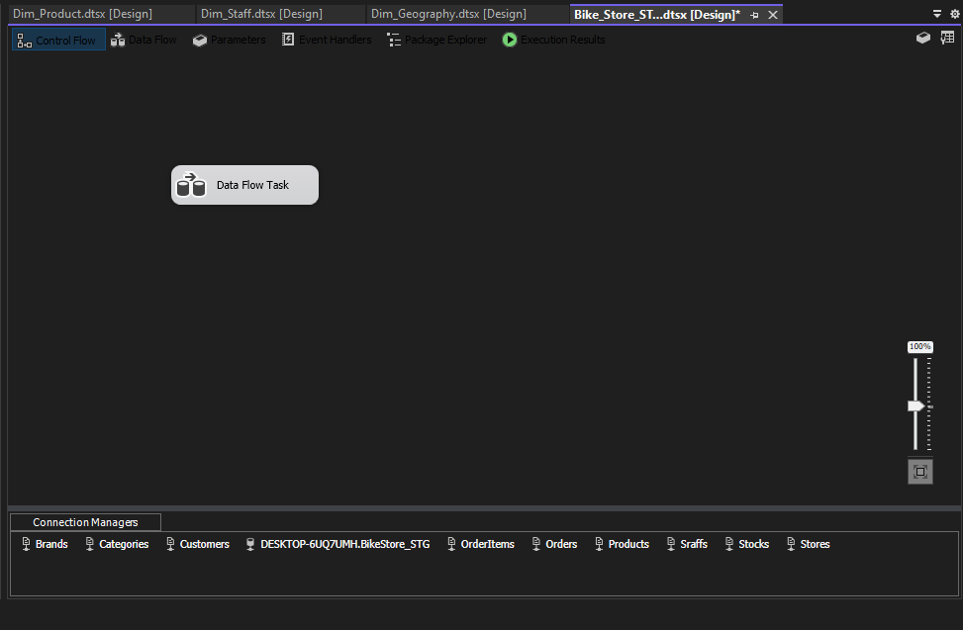
  - Title: STG Load — CSV Flat Files to Staging (9 Tables)

- Bike_Store_STG:
  - Flow Type: is Data Flow
  - Title: STG Load — Data Flow Overview
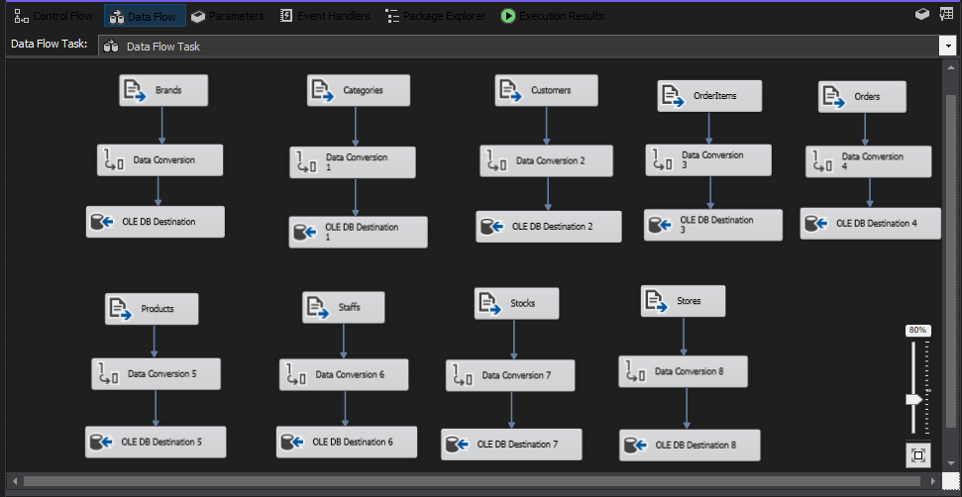
  - Description: Loading the source, cleaning and placing them in the BikeStore_STG database

- Dim_Date.dtsx:
  - Flow Type: Control Flow
  - Title: Dim_Date — Execute SQL Task to Populate Date Dimension
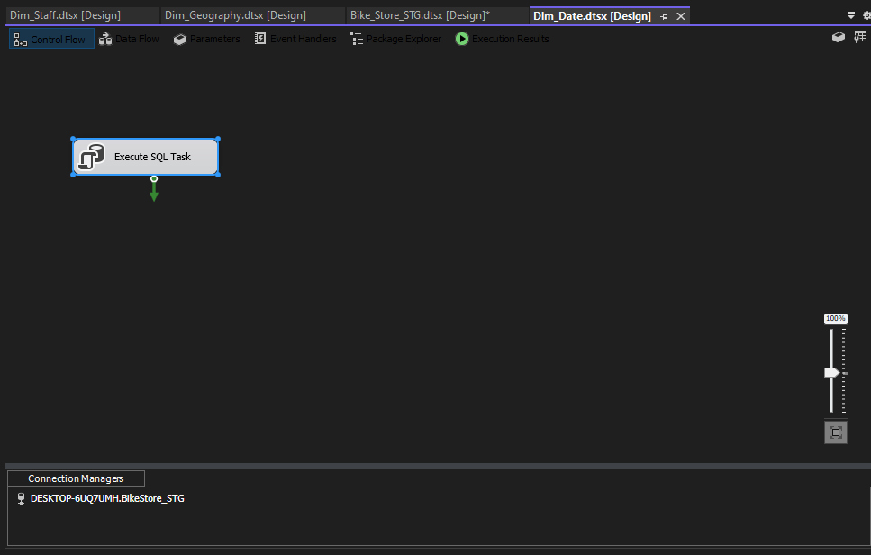
  - Description: It is built once via an SQL WHILE loop to build and populate the date dimension. It iterates day-by-day from 2016-01-01 to 2018-12-31. Populates DateKey (int), FullDate, Year, Quarter, Month, MonthName, Day, DayOfWeekName, IsWeekend. No SSIS Data Flow needed as historical dates never change.
- Dim_Customer.dtsx
  - Flow Type: Control Flow
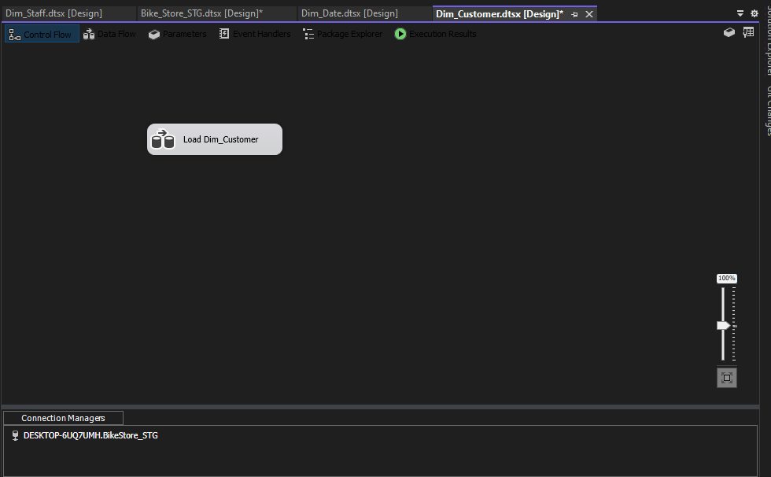
  - Title: Dim_Customer — Control Flow Overview

- Dim_Customer.dtsx:
  - Flow Type: is Data Flow
  - Title: Dim_Customer — SCD Type 1: Insert New Customers Only
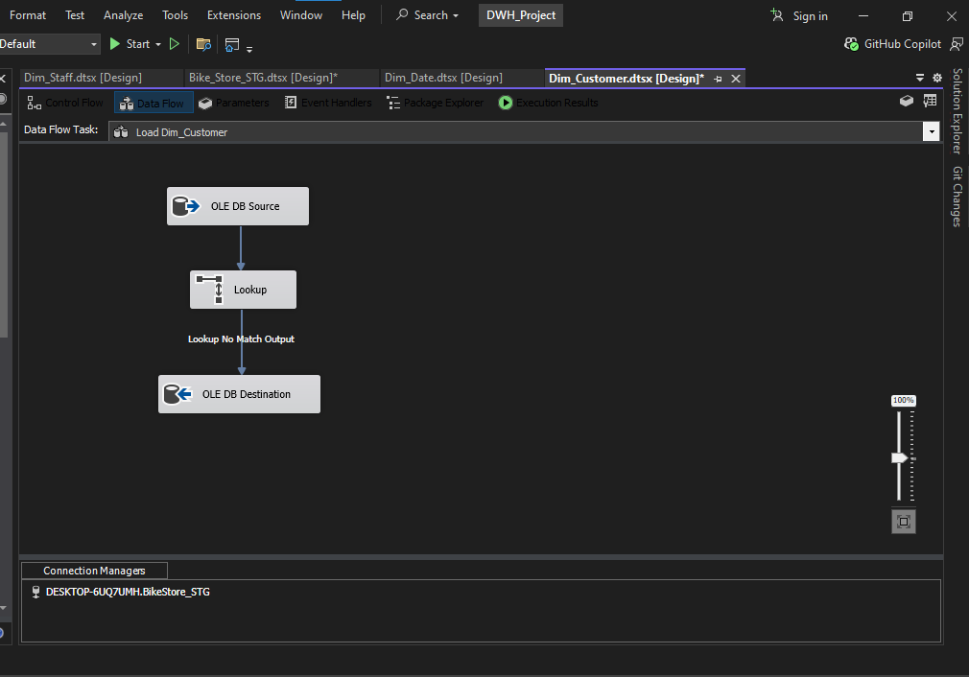
  - Description: The source is STG_customers (customer_id, first_name, last_name, email, phone). Lookup matches on Customer_Source_ID. Only the No Match Output is routed to the OLE DB Destination (new customers inserted). Match Output is discarded as existing records are never updated. This is done using SCD Type 1 insert-only pattern.
- Dim_Geography.dtsx:
  - Flow Type: Control Flow
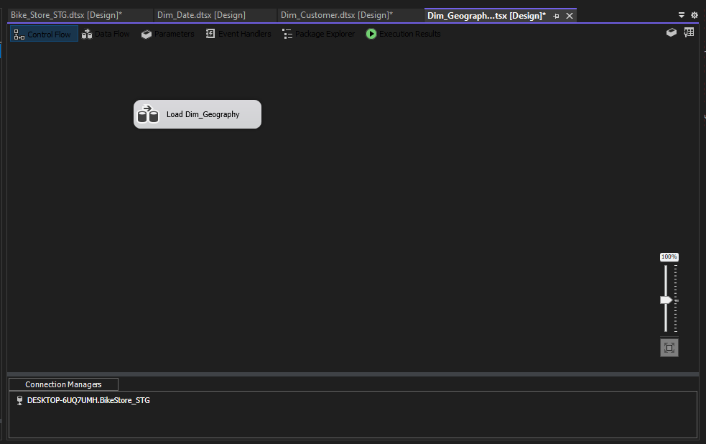
  - Title: Dim_Geography — Control Flow Overview

- Dim_Geography.dtsx:
  - Flow Type: Data Flow
  - Title: Dim_Geography — SCD Type 1: Insert New Stores Only
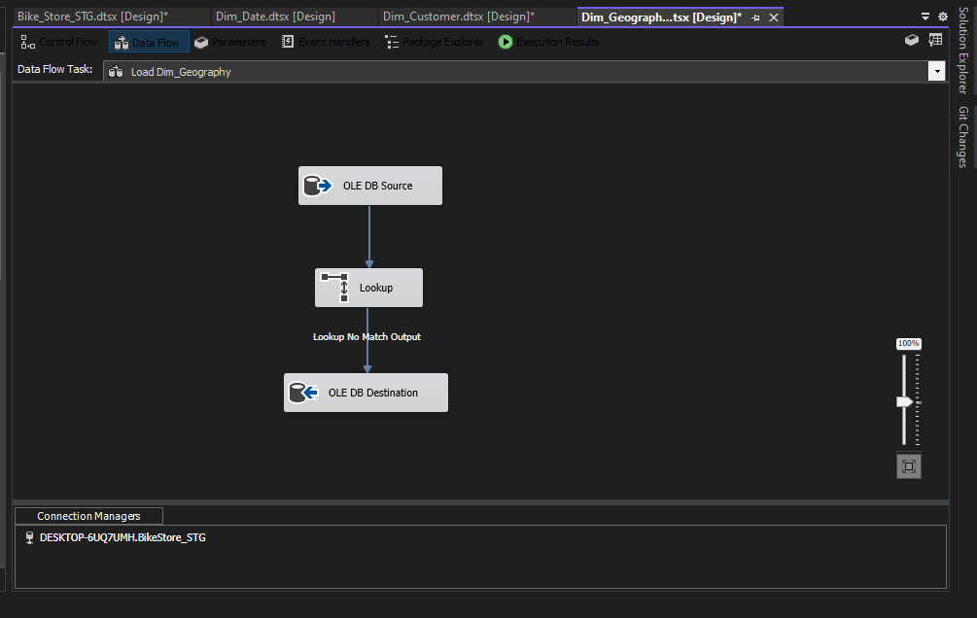
  - Description: The source is STG_stores (store_id, store_name, city, state, zip_code). Lookup matches on Store_Source_ID. Only the No Match Output records are routed to destination. Store location data is static in the BikeStore dataset as there are no store relocations nor will the current data set change, so we only insert and don’t update.

- Dim_Order_Status.dtsx:
- Flow Type is Control Flow
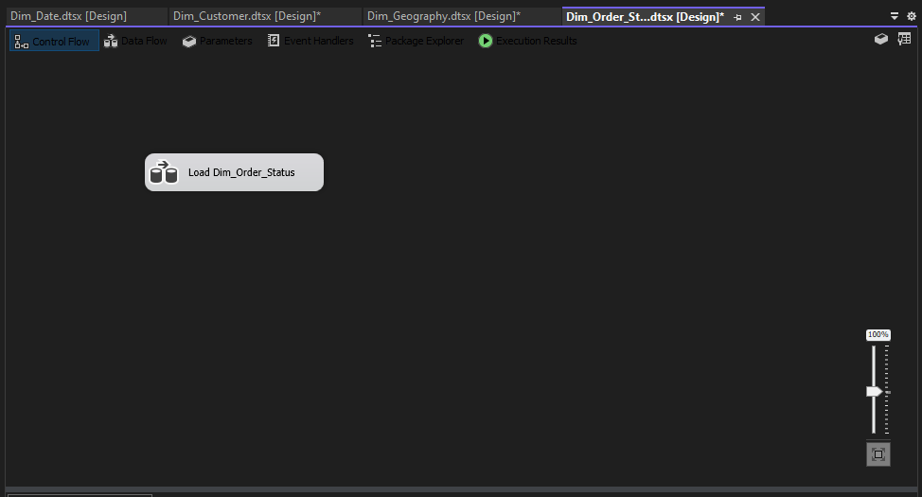
- Title: Dim_Order_Status — Control Flow Overview

- Dim_Order_Status.dtsx:
  - Flow Type: Data Flow
  - Title: Dim_Order_Status — Static Load with Derived Status Descriptions
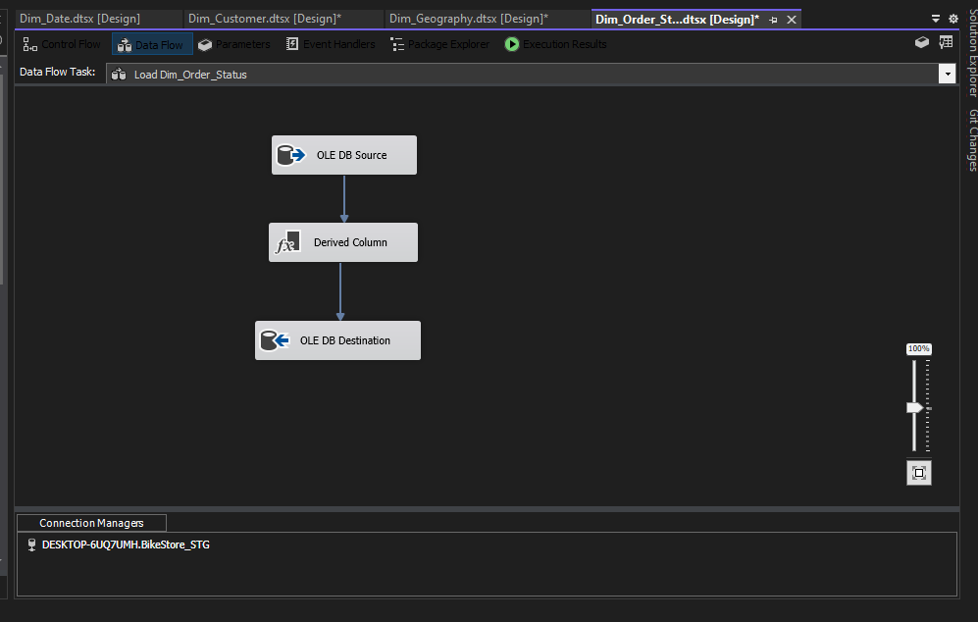
  - Description: The source is the ‘DISTINCT’ order_status values from STG_orders. Derived Column maps the integer codes to text descriptions: 1→"Pending", 2→"Processing", 3→"Rejected", else→"Completed" and this produces Status_Description column. Static lookup table — no versioning needed.
- Dim_Product.dtsx:
  - Flow Type: Control Flow
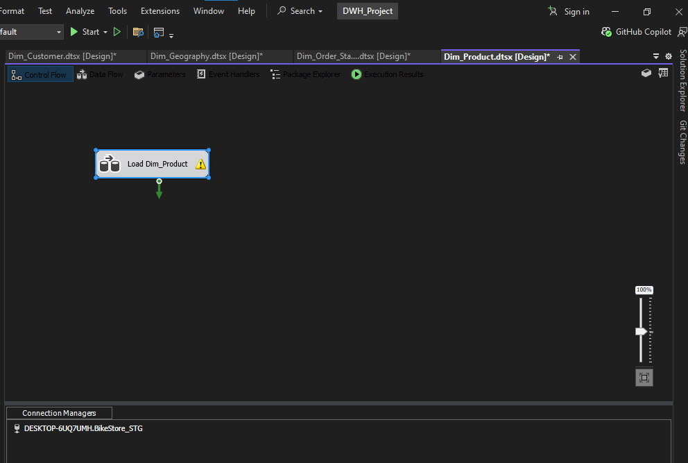
  - Title: Dim_Product — Control Flow Overview

- Dim_Product.dtsx:
  - Flow Type: Data Flow
  - Title: Dim_Product — SCD Type 2: Full Version Tracking
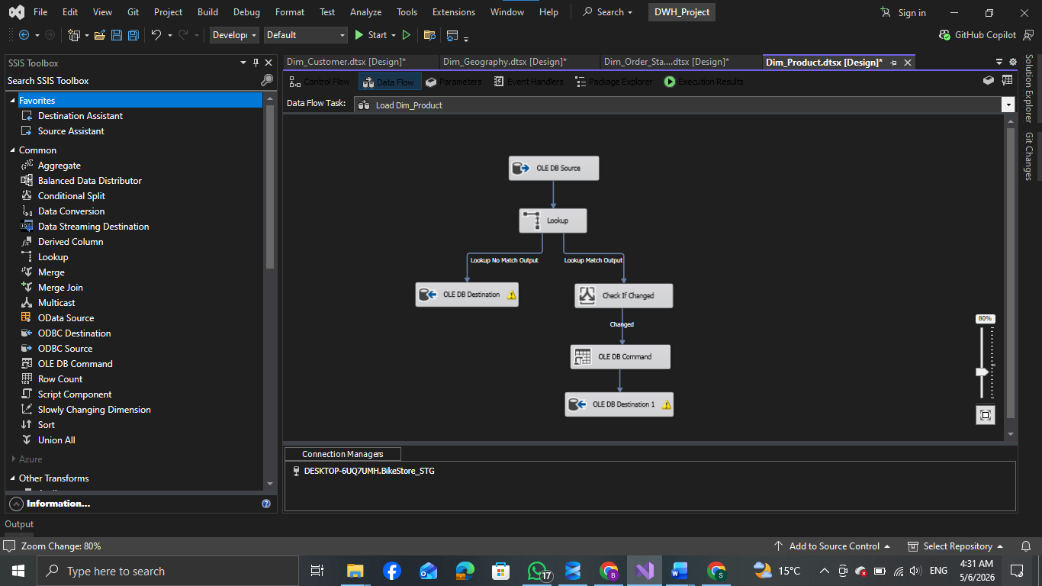
  - Description: The source is STG_products JOIN STG_categories JOIN STG_brands. Lookup matches on Product_Source_ID. If there is no Match then insert new row (new product). Else if there is a match and something changed (product_name OR category_name OR brand_name OR model_year) then the OLE DB Command runs UPDATE to expire old row (EndDate=GETDATE(), IsCurrent=0), then new row inserted with IsCurrent=1. Else if there is a match and no change then the row is discarded. DDL includes StartDate, EndDate, IsCurrent columns on Dim_Product.

- Dim_Staff.dtsx:
  - Flow Type: Control Flow
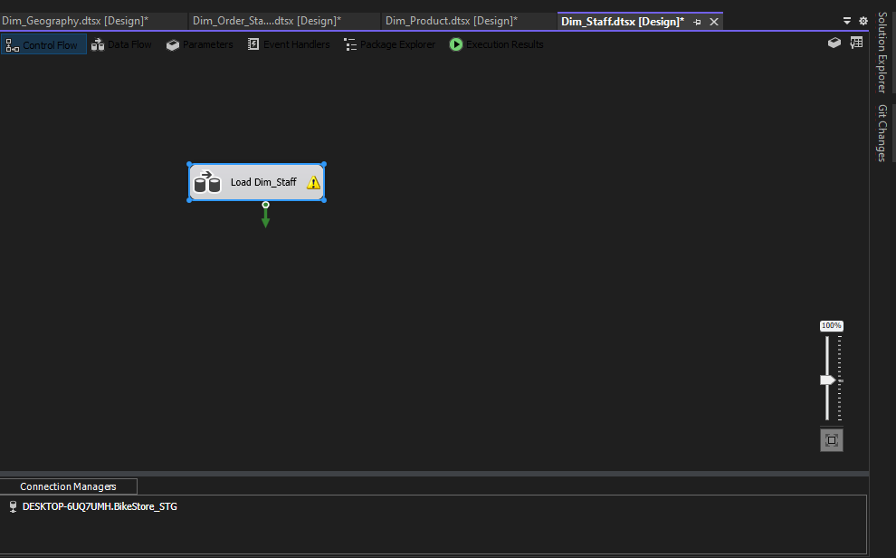
  - Title: Dim_Staff — Control Flow Overview

- Dim_Staff.dtsx:
- Flow Type: Data Flow
- Title: Dim_Staff — SCD Type 2: Full Version Tracking with ISNULL Handling
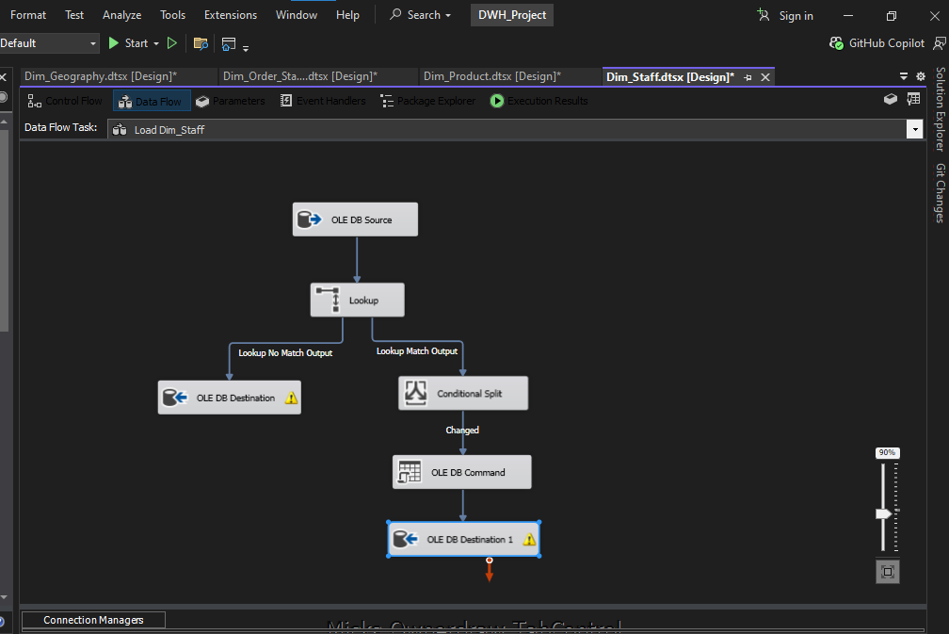
- Description: The source is STG_staffs with ISNULL handling (first_name+last_name → Staff_Name, email → Staff_Email, active → Active_Status). Lookup matches on Staff_Source_ID. If there is no match then insert new row. Else if there is a match and has been changed (Staff_Name OR Staff_Email OR Active_Status), then expire old row and insert the new one. Else if there was a match and wasn’t changed then discard the row. DDL includes StartDate, EndDate, IsCurrent columns on Dim_Staff.
- Fact_Sales.dtsxà Flow Type is Control flow
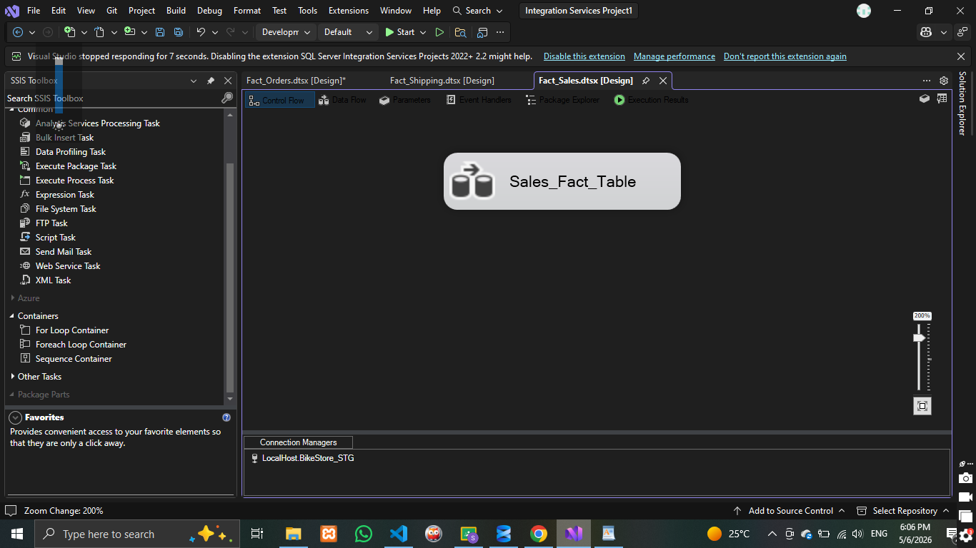
- Fact_Sales.dtsx:
  - Flow Type: Data flow
  - Description: Records individual product sales events to track detailed revenue and discount metrics. The SSIS ETL pipeline extracts data from staging, computes net revenue directly at the source engine, and enforces Referential Integrity using sequential Lookup Transformations against the customer, product, geography, and date dimensions. Only verified transactions pass through the Lookup Match Output, where operational IDs are swapped for optimized data warehouse to surrogate keys before being loaded into the destination table for executive KPI reporting.
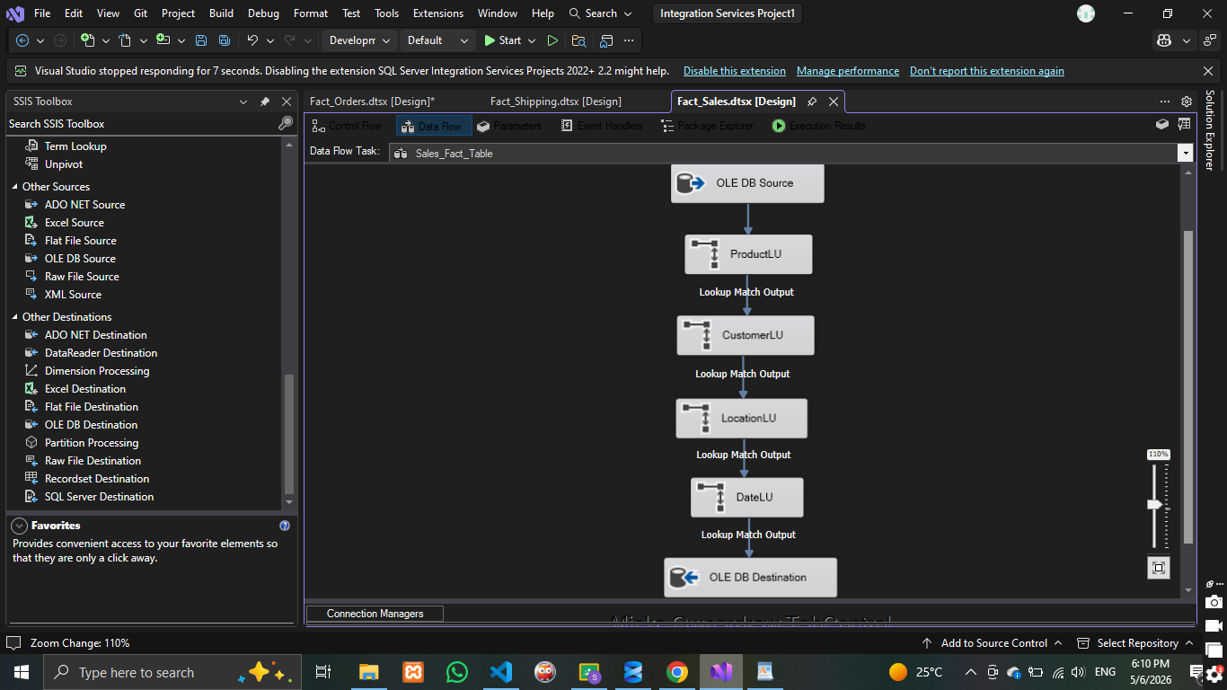
- Fact_Shipping.dtsx:
  - Flow Type: Control flow
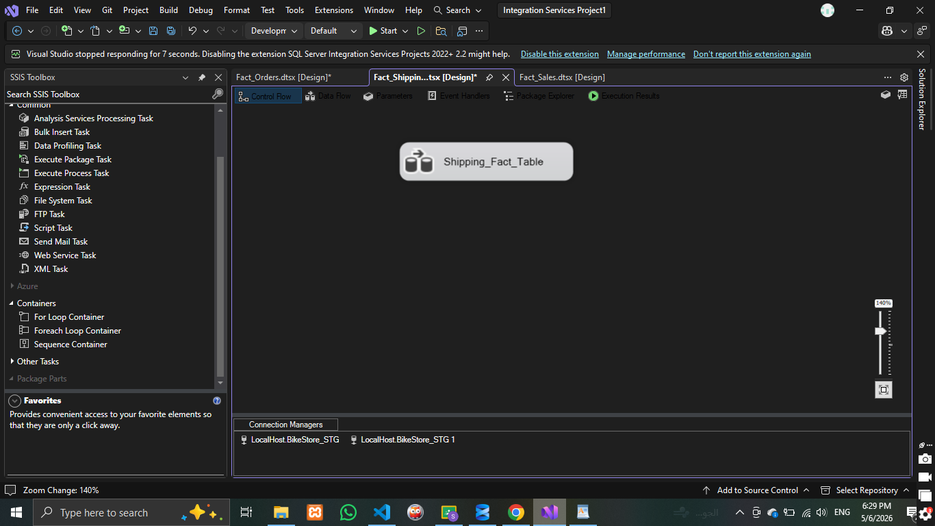
- Fact_Shipping.dtsx:
  - Flow Type: Data flow
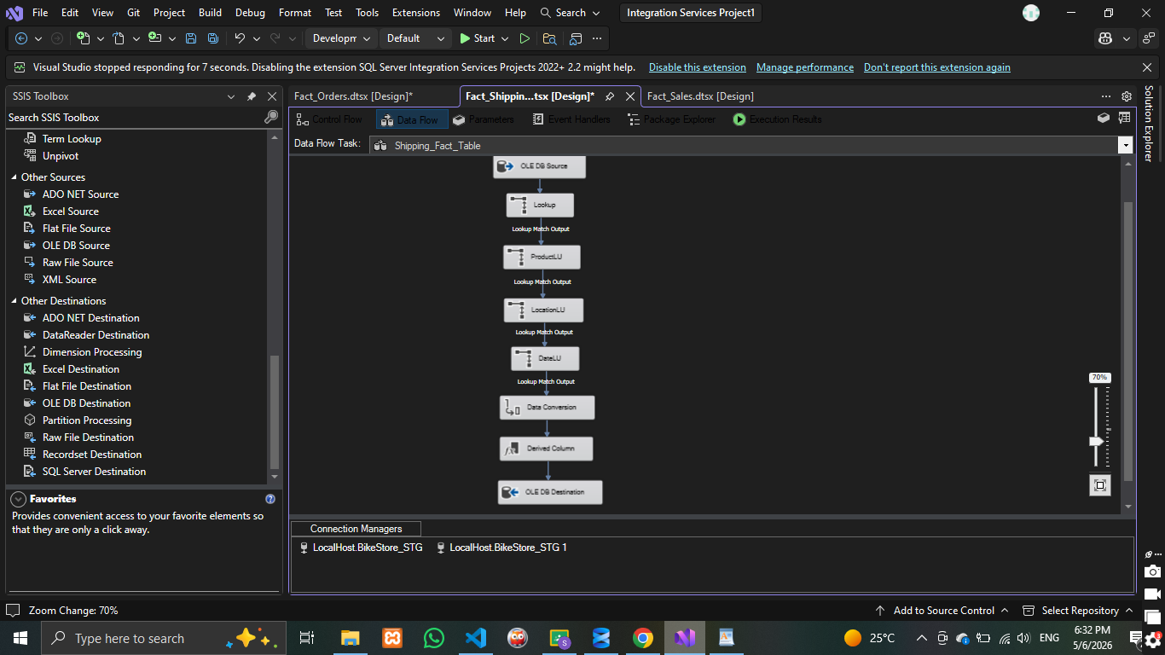
  - Description: Captures the logistics and fulfillment lifecycle to measure delivery performance. The SSIS ETL pipeline extracts delivery records from the staging layer and calculates operational time, such as the actual processing days and late shipment flags

- Fact_Order.dtsx:
  - Flow Type: Control flow
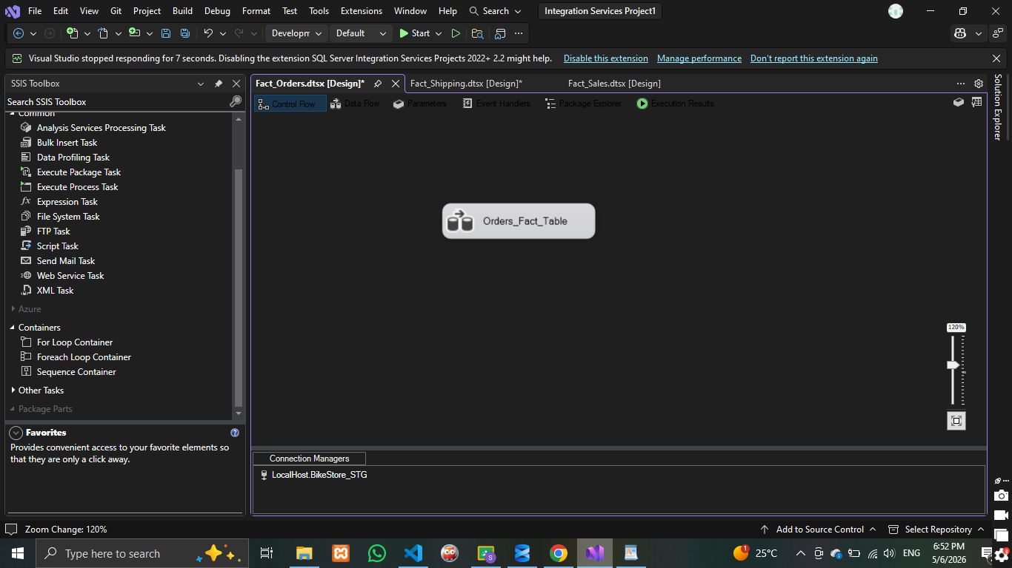

- Fact_Order.dtsx:
  - Flow Type: Data flow
  - Description: It summarizes the financial and status outcomes of the entire transactions. The SSIS pipeline uses an aggregation method to on individual line items, calculating total order value and total item counts. Verified orders are mapped to the data warehouse to surrogate keys and loaded into the destination table to track KPIs like average order value, basket size, and order success rates.
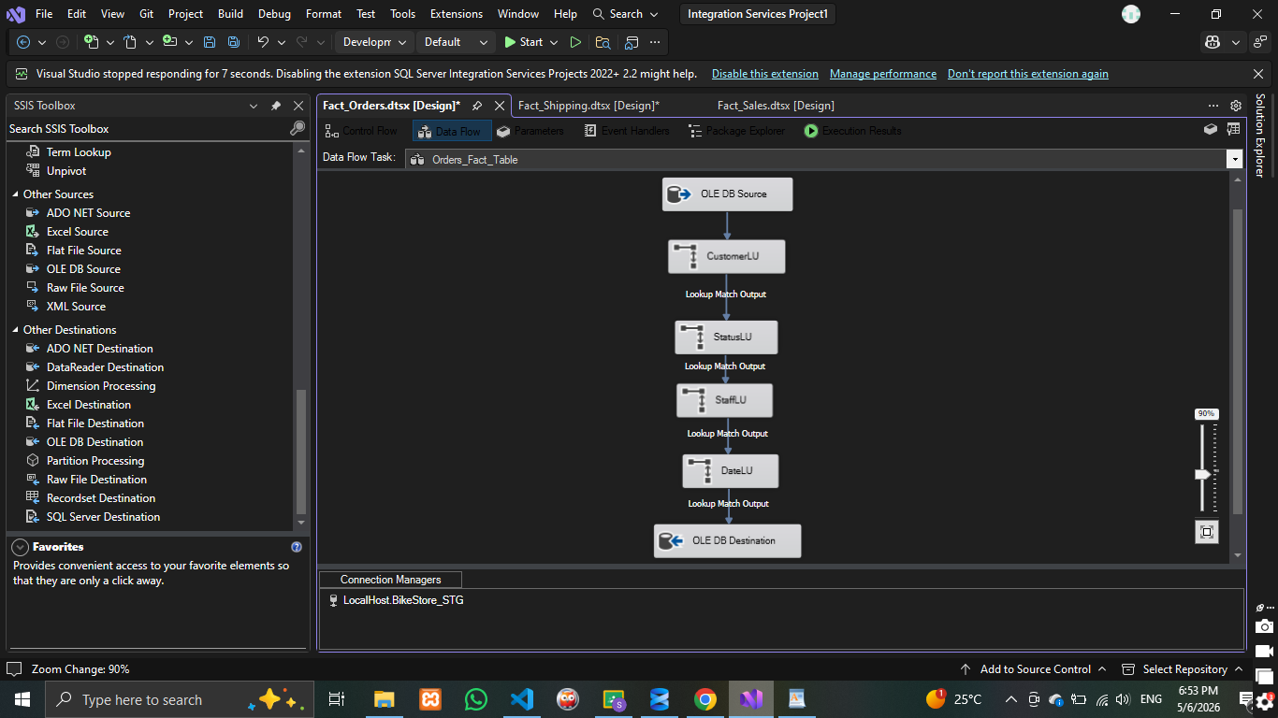
- Queries on each fact table
- Fact_Sales queries: -
- Top Selling Products by Quantity.
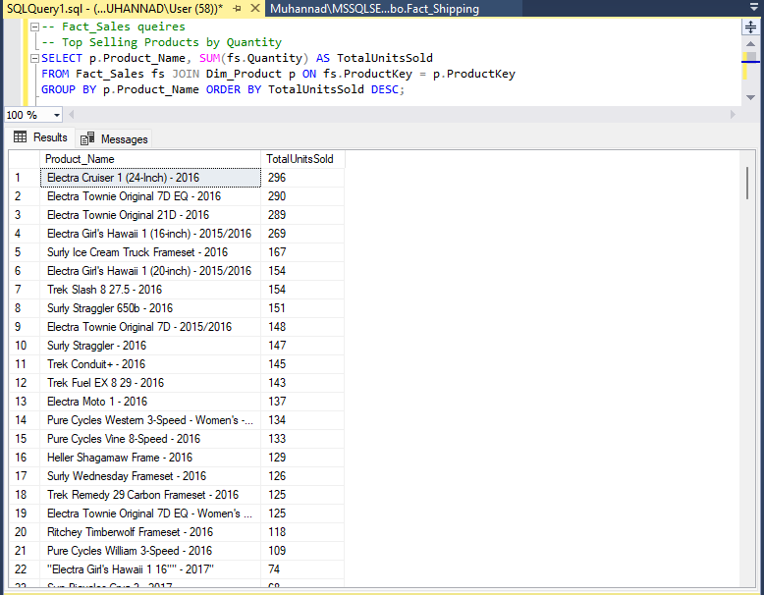
- Total Net Revenue by Brand.
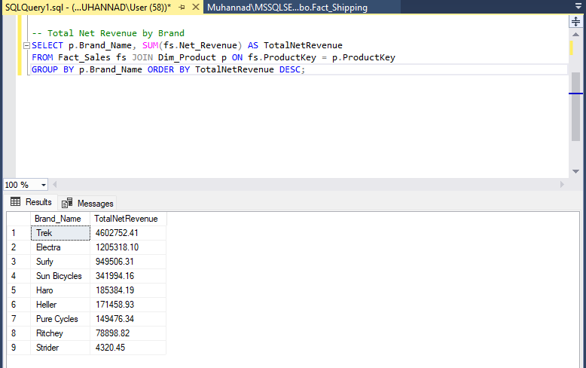

- Fact_Shipping queries:-
- Late Shipment Rate per Store.
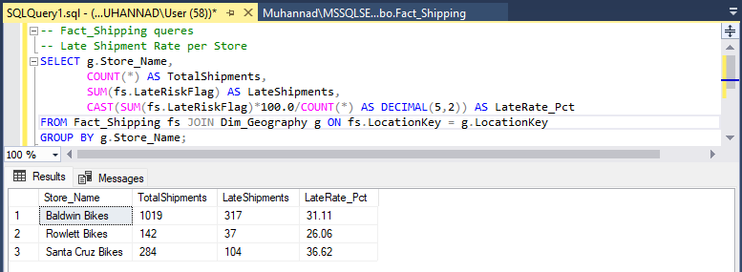
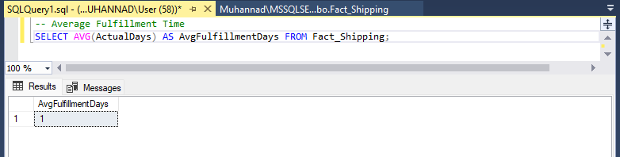
- Average Fulfillment Time.

- Fact_Orders queries:-
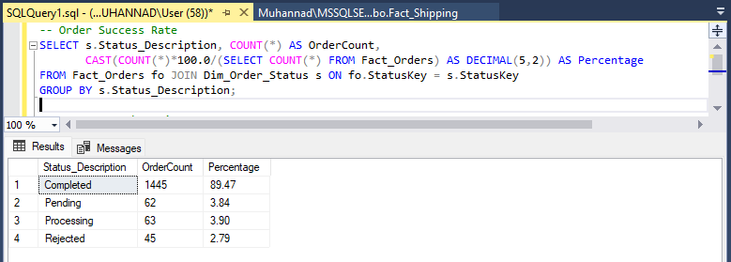
- Order Success Rate.

- Average items count.
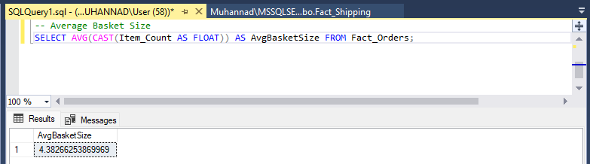
- Screenshots of the deployed packages in SSIS with their schedule.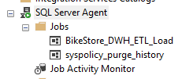
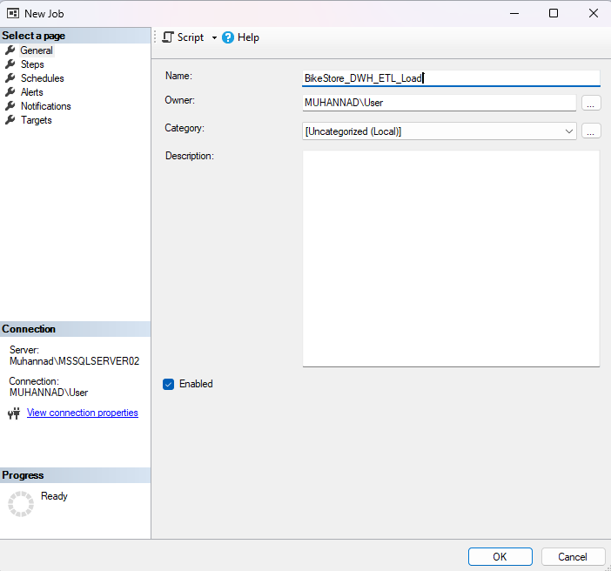
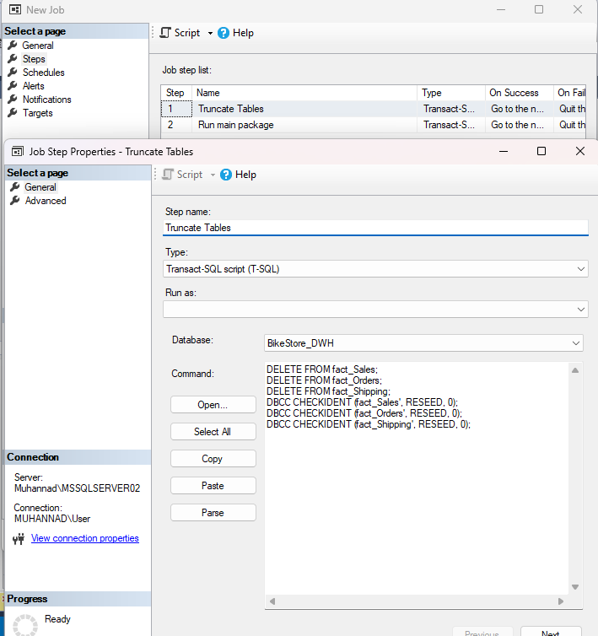
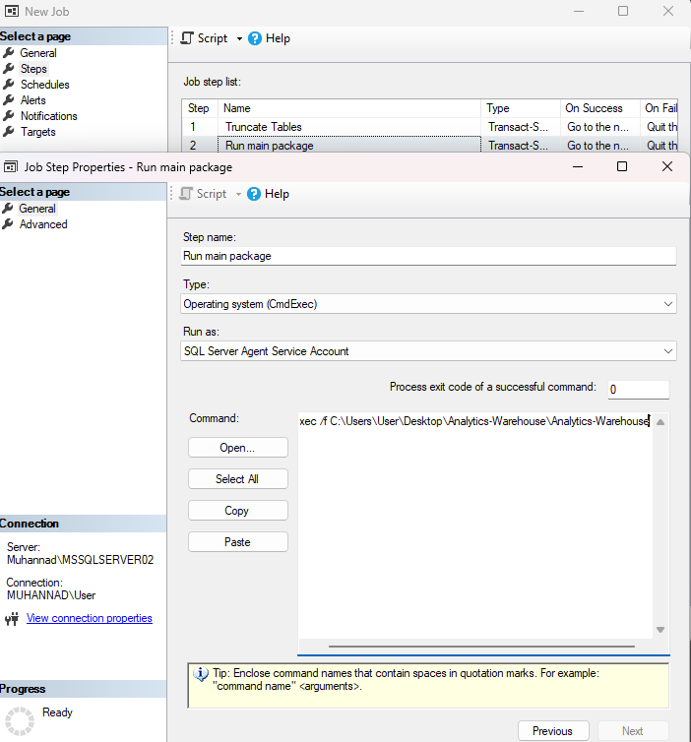
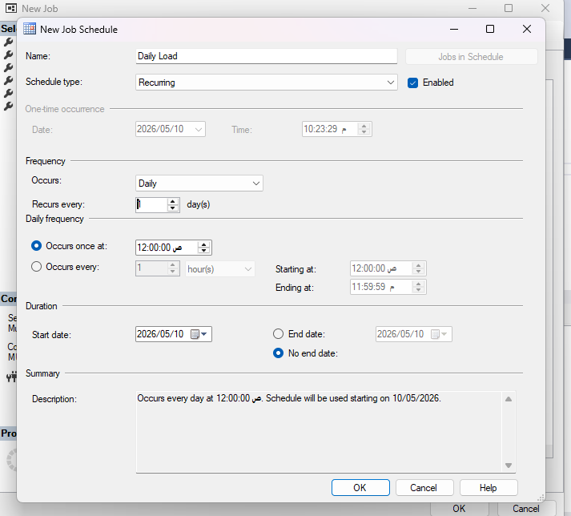
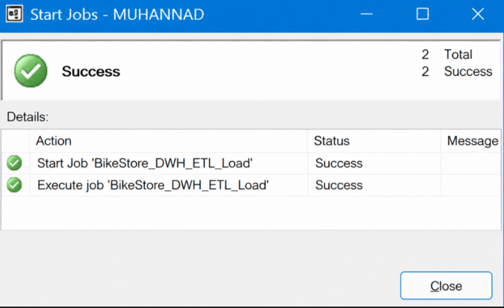

- Build an interactive dashboard for the DWH
Sales Performance Page:
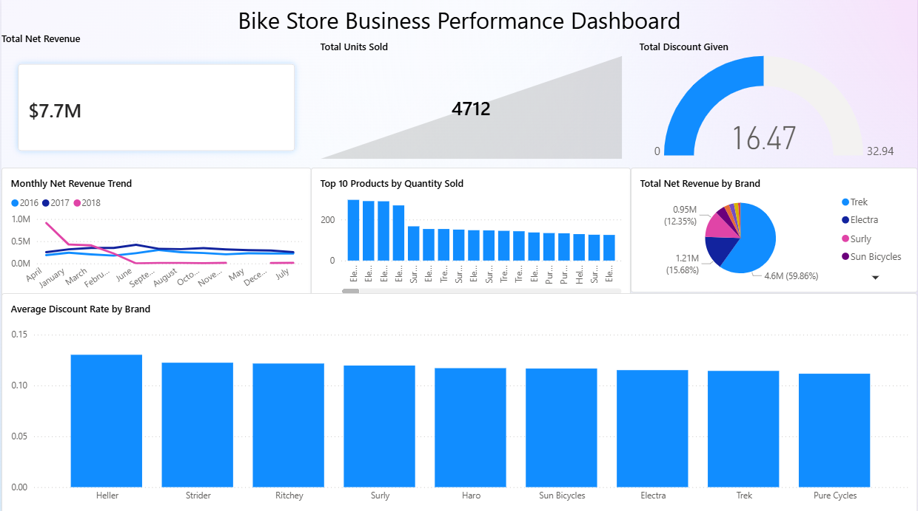
Shipping & Logistics Page:
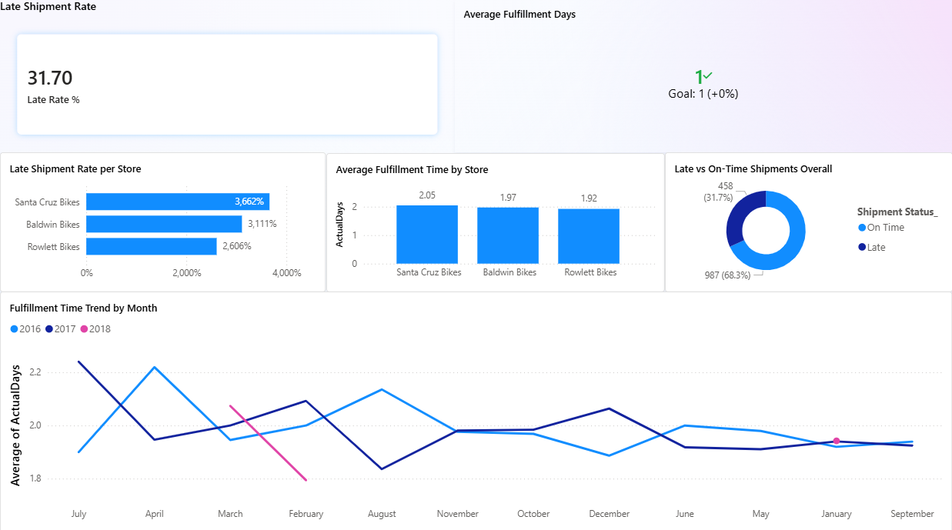

Order Management Page:
